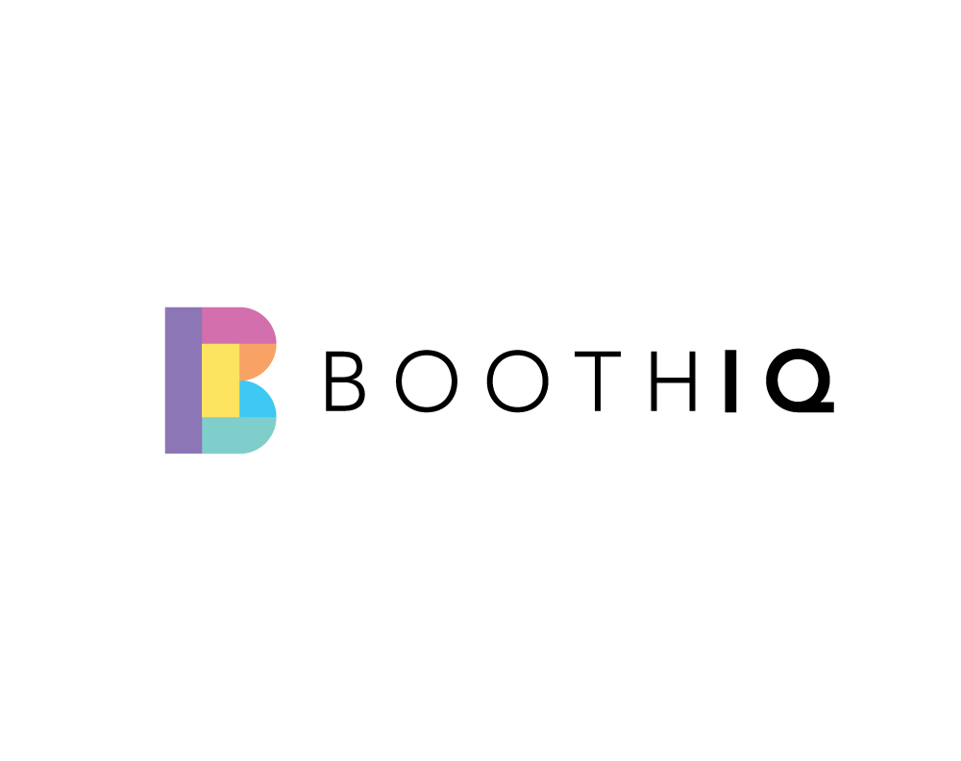

Hey there,

Thank you for partnering with BoothIQ.

We’re thrilled to be working with you!

We’ve created social media templates for you to announce this partnership to your community. You can find them on the pages below.

Right click each photo and click ‘save as picture’ to save them on your computer.

Happy to help!

Team BoothIQ.

Instagram & Facebook templates.

General
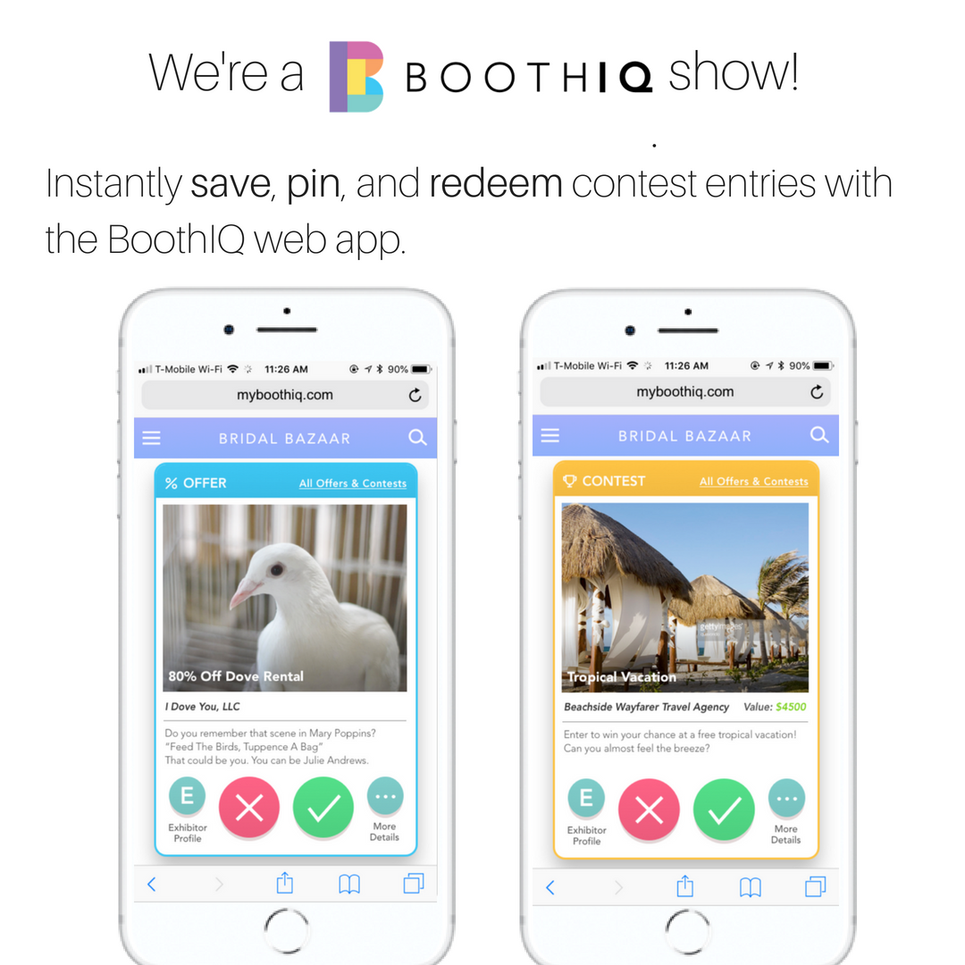

Bridal
